**Nhóm 29**

Cổ Lê Anh Duy - 44.01.104.006

Nguyễn Thành Duy - 44.01.104.070

Nguyễn Thị Uyển Cương - 44.01.104.058

Nguyễn Dương Hồng Diệu - 44.01.104.004

**HÌNH THỨC LIÊN LẠC GIỮA CÁC THÀNH VIÊN**

**1/ Hình minh họa nhóm Chat (Facebook Messenger)**

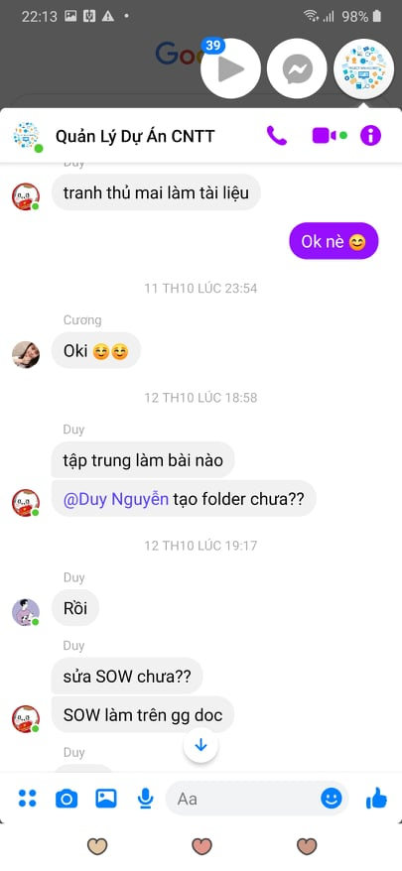

**2/ Mẫu Email**

**\*Email phàn nàn từ thành viên:**

**From:** [duy3271@gmail.com](mailto:duy3271@gmail.com)

**To:** [duyclad@gmail.com](mailto:duyclad@gmail.com)

**Cc:** [nguyenthiuyencuong@gmail.com](mailto:nguyenthiuyencuong@gmail.com) ; [hongdieupvt2000@gmail.com](mailto:hongdieupvt2000@gmail.com)

**Bcc:**

**Subject:** [Assignment of work] Assignment of work uneven among members.

Dear Mr.Anh Duy,

My name is Thanh Duy - members of the group 29: Game Caro.

I have a question about the project we got 2 days ago. So I ask permission to present.

Today, I realize that my assigned workload is too much compared to member Uyen Cuong in the project. I have to do 25 tasks in the project but Uyen Cuong only does 15 tasks. Can you check the workload I was assigned to or give me a reason for it?

Thank you,  
Thanh Duy

--------------------------------------------

Members of group 29: Nguyen Thanh Duy  
Phone Number: +84977406090  
Email: [duy3271@gmail.com](mailto:duy3271@gmail.com)

**\*Mail Trả lời:**

**From:** [duyclad@gmail.com](mailto:duyclad@gmail.com)

**To:** [duy3271@gmail.com](mailto:duy3271@gmail.com) ; [nguyenthiuyencuong@gmail.com](mailto:nguyenthiuyencuong@gmail.com)

**Cc:** [hongdieupvt2000@gmail.com](mailto:hongdieupvt2000@gmail.com)

**Bcc:**

**Subject:** [Reply] Assignment of work uneven among members.

Dear Mr.Thanh Duy and Ms.Uyen Cuong,

I have read Thanh Duy's complaint email about the problem he is facing.

First of all, I would like to thank you for your comments.

I am looking at the problem you are having. To be able to solve this problem, I would like to hold a meeting for all members of this project on the problem you are having.

Meeting will be held tomorrow (14:00 October 26, 2020). All members please join this meeting.

Any questions about meeting time please contact me.

Thank you,  
Anh Duy

-----------------------------------------

Project Manager of Group 29: Co Le Anh Duy  
Phone Number: +84969376729  
Email: duyclad@gmail.com

**3/ Hình minh họa cuộc họp online (Google meet)**

